Minnesota State Park Travel Guide

# Fort Snelling State Park

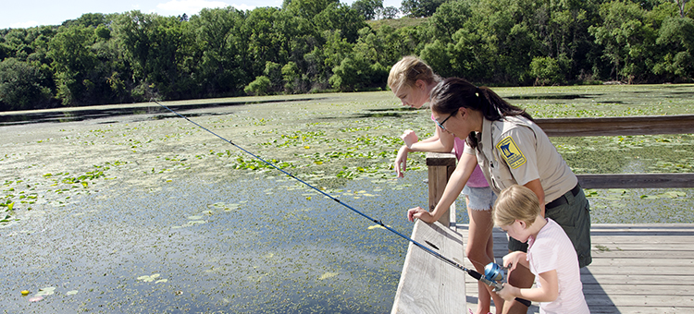

# Highlights

* Fishing
* Hiking
* Dakota Memorial
* Interpretive Exhibits
* Bike Trails/Connections
* Cross-Country Skiing

# Geology

Generations of Dakota lived in villages along the Mississippi and Minnesota Rivers that meet in Fort Snelling state park, long before Europeans arrived. The river confluence was believed to be the place of origin and center of the earth by the bands of Mde-wa-kan-ton-wan Dakota, the "Dwellers by Mystic Lake." By the late 1600s, Europeans had visited the area. In the 1820s, historic Fort Snelling was built on the bluff above the two historic rivers to control the exploration, trade, and settlement on these waterways. 2012 marked 150 years since the U.S.-Dakota War of 1862. Fort Snelling State Park was an important location during this time. Find out how to learn more.

# History

The forest bottoms and marshes are home to an abundance of wildlife, including white-tailed deer, fox, woodchucks, turkeys, and coyotes. Visitors might also come across a fox snake which is almost identical in appearance to a rattle snake, but is not venomous. Snapping, soft-shelled and painted turtles can be seen basking in the sun along the river or in one of the lakes.

# Landscape

The area was established as a state park in 1961. The swimming beach, added in 1970, remains a popular recreation attraction in the park. In 1997, a new visitor center opened to the public.

# Park Information

Located in the heart of the Twin Cities, this park offers extensive hiking, bike, snowshoe, and ski trails that link to an extensive regional trail system. Canoe, fish, or swim on Snelling Lake or hike on Pike Island where the Mississippi and Minnesota Rivers meet. Interpretive exhibits at the Thomas C Savage Visitor Center provide a good introduction to the history and resources of the park area.

# Wildlife

This is a day-use only park; no camping is available.



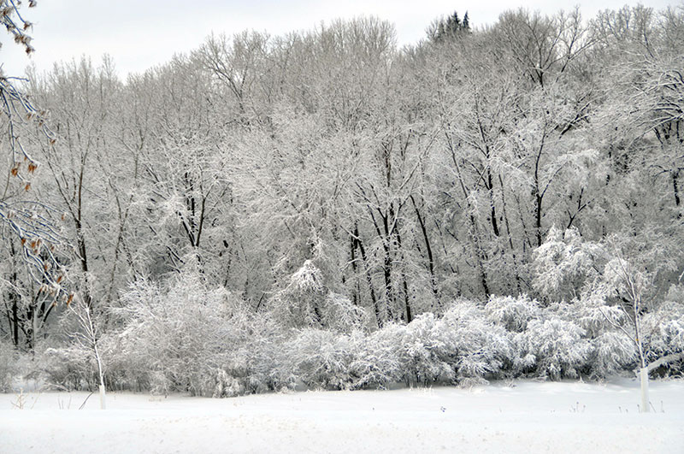

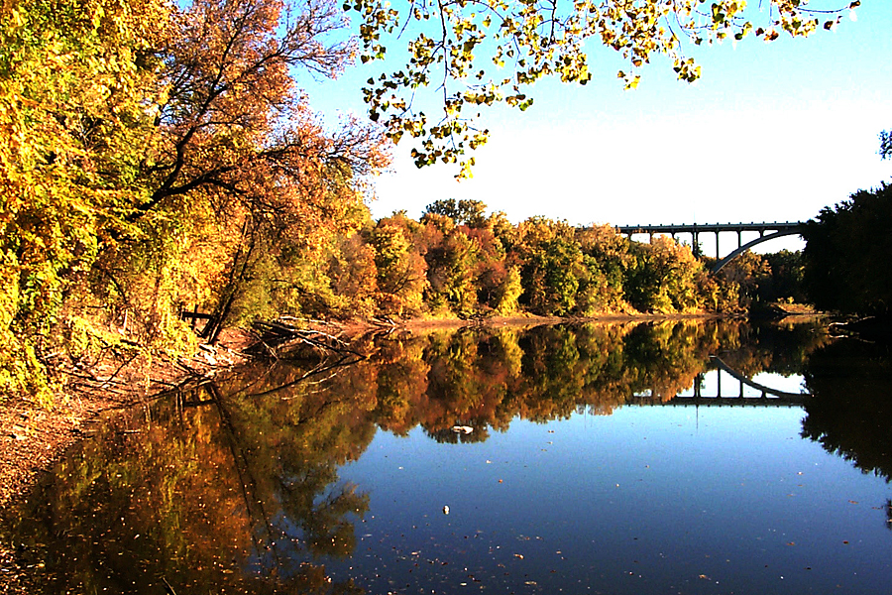

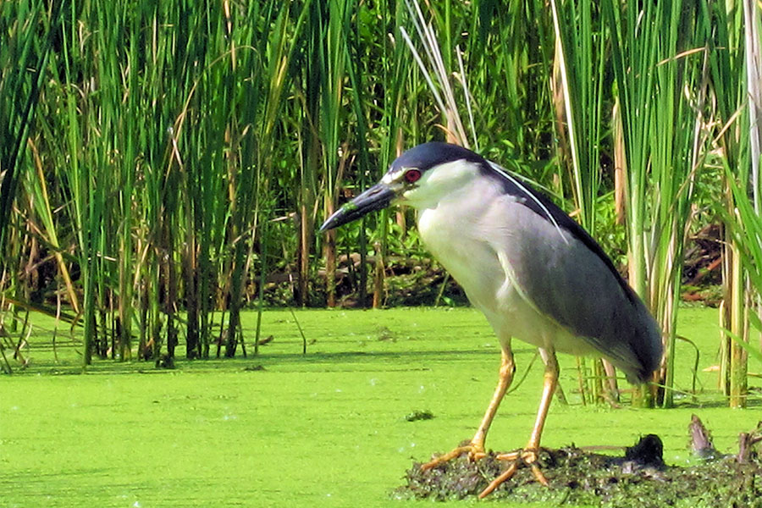



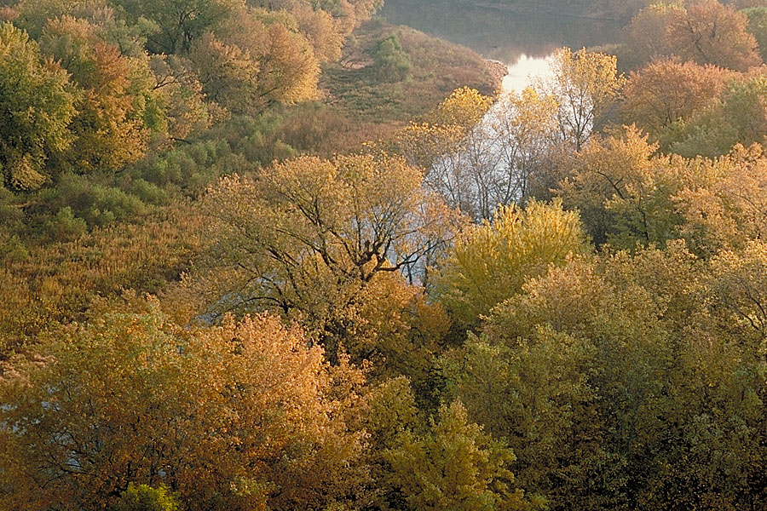

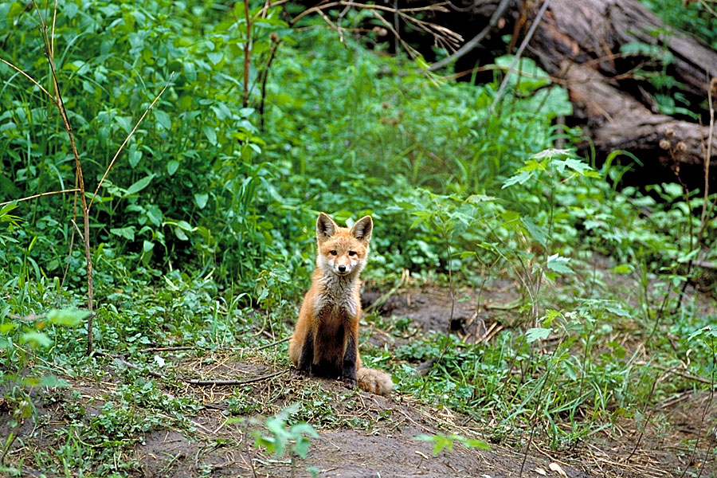

# Contact Information

## Address

101 Snelling Lake Road  
St. Paul, MN 55111

### Website

https://www.dnr.state.mn.us/state_parks/park.html?id=spk00154#homepage

# Grand Portage State Park

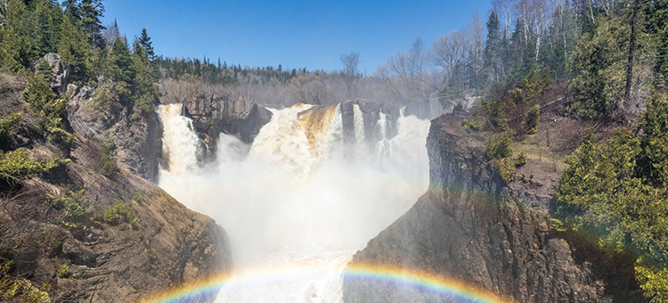

# Highlights

* Minnesota's Highest Waterfall
* Hiking
* Scenic Views
* Picnicking
* Spring/Summer Wildflowers

# Geology

The geology of High Falls is a story of fire and ice. According to geologists, it begins in the middle of the Precambrian Era about 1.9 billion years ago. An ancient sea covered much of what is now Minnesota, and deposited mud and sand that hardened over time into a thick layer of bedded shales and sandstones known as the Rove Formation. These are the layered rocks you can see along the highway northeast of Grand Portage as well as along the gorge of the Pigeon River below the falls. About 1.1 billion years ago, the continent began to spread along a rift that extended from what is now eastern Lake Superior to Kansas. Basaltic lava poured out along this zone, making most of the rocks along the North Shore, while here in Grand Portage, diabase intrusions penetrated the older Rove shales along large vertical fractures, forming dikes. The High Falls of the Pigeon River are made by a diabase dike that is very resistant to erosion, especially compared to the surrounding Rove shales. Much later, starting about 2 million years ago, great glaciers, originating in Canada, advanced many times into this area, with warmer interglacial climates between each advance. The most recent glacial retreat occurred only around 10,000 years ago. Water filled the huge basin (now occupied by Lake Superior) that had been scooped out by the glaciers, and the land under and around the basin gradually rebounded from the weight of the ice and the lake level slowly receded.

# History

Git-che-O-ni-ga-ming and Grand Portage are Ojibwe and French words for "a great carrying place." Grand Portage State Park and the surrounding area is rich in Indian and fur trade history. To American Indians, voyageurs and fur traders in the 1700s, the natural features of the area were an awesome sight. Travelers and traders were faced with a 120-foot waterfall, the thundering rapids of the Pigeon River, cliffs, and rocky terrain that was impossible to cross. The only option was to go around these obstacles. The nine-mile trek became known as "The Grand Portage" and ultimately gave the area its name. The park lies within the Grand Portage Indian Reservation and is bordered by Canada on the north and east. Lake Superior is about one mile east of the park. The park was established in 1989 through the cooperative efforts of the State of Minnesota and the Grand Portage Band of Chippewa Indians. A unique situation exists in that this is the only state park not owned by the State of Minnesota. The land is leased from the Bureau of Indian Affairs (BIA) which holds it in trust for the Grand Portage Band. The development and operation of the park rests primarily with the Department of Natural Resources and is implemented through the Division of Parks and Recreation.

# Landscape

The ridges around Grand Portage State Park would have first emerged as an isolated group of offshore islands. As centuries passed, gravel was deposited in terraces by the retreating lake. The path to High Falls cuts directly through one of these gravel terraces. About 9,000 years ago, the lake level dropped to a point where the river mouth would have been at the lower end of the High Falls gorge. If High Falls is a post-glacial landform, then the gorge is only about 9,000 years old. There is speculation among geologists that the gorge was cut before the glaciers came, filled with sediment, and was re-excavated after the lake level dropped. There is evidence for this happening in several other North Shore river valleys.

# Park Information

Torrents of wild water plummet 120 feet over the High Falls down to the Pigeon River in this park on the U.S. - Canadian border. The falls, the highest in the state, presented a serious obstacle to river travel, so a "carrying place," or portage, was necessary. American Indians created the ancient nine-mile trail from Lake Superior to bypass the falls. This trail became known as "The Grand Portage." Today, visitors of all abilities can take a one-half mile trail and boardwalk to the falls overlook area. The park is designed for day use only and contains mixed hardwood-conifer forests and hiking trails along the banks of the Pigeon River. The spectacular scenery sets the stage for recreational opportunities that include hiking, photography, and picnicking. The park lies within the Grand Portage Indian Reservation and is bordered by Canada on the north and east. Lake Superior is about one mile east of the park.

# Wildlife

The glacial ridges in the park add to a varied terrain which harbors an abundance of wildlife. The channeled bays and river islands below the falls are home to osprey, eagle, otter, beaver, moose, and great-blue heron. Visitors can expect to see white-tail deer and black bear along with other small animals and birds.



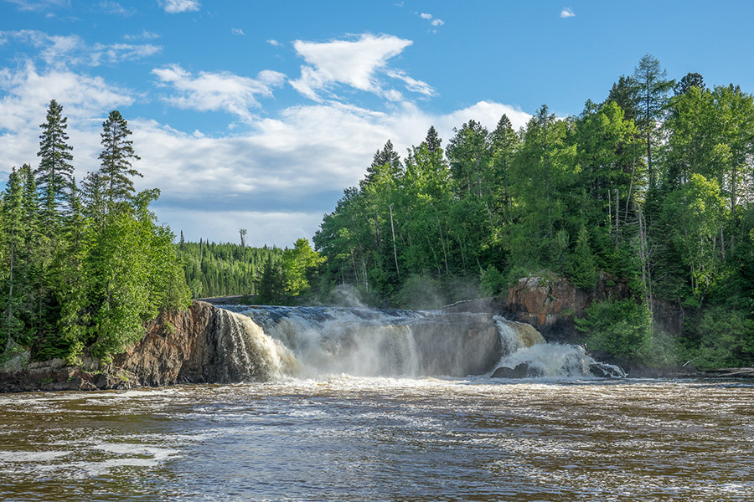

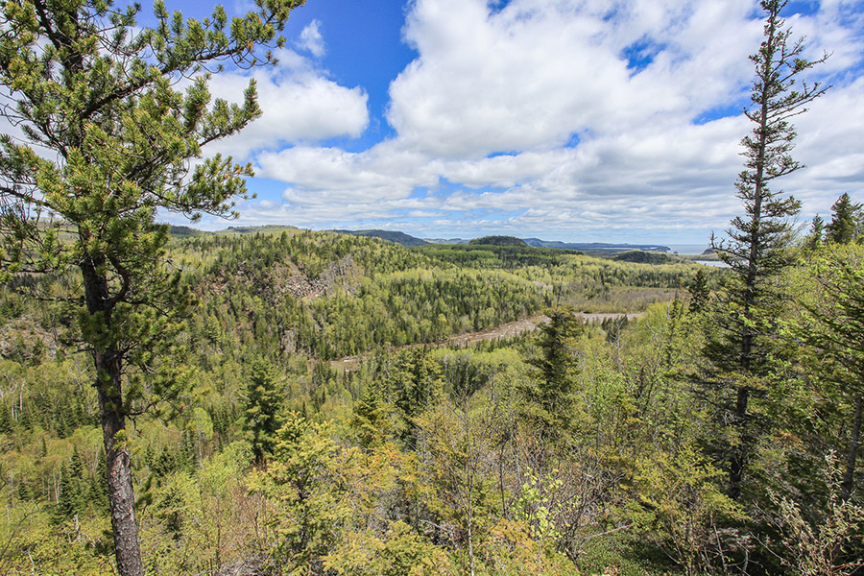

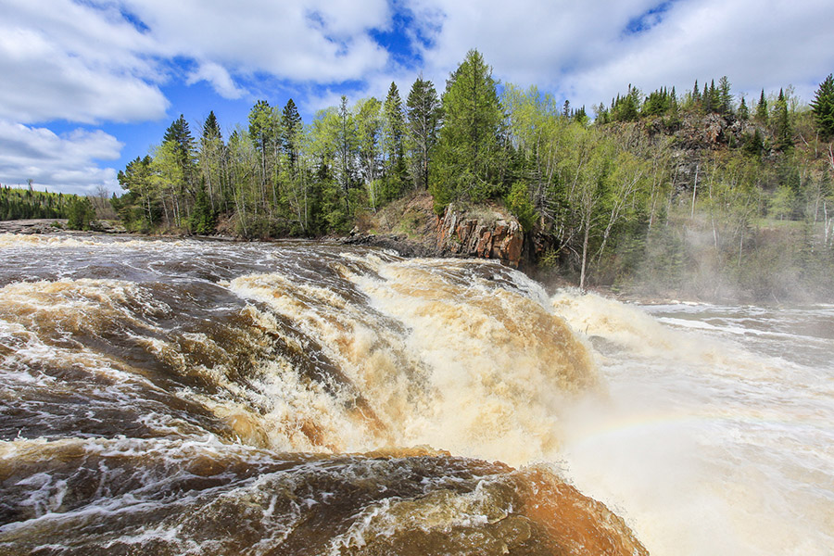

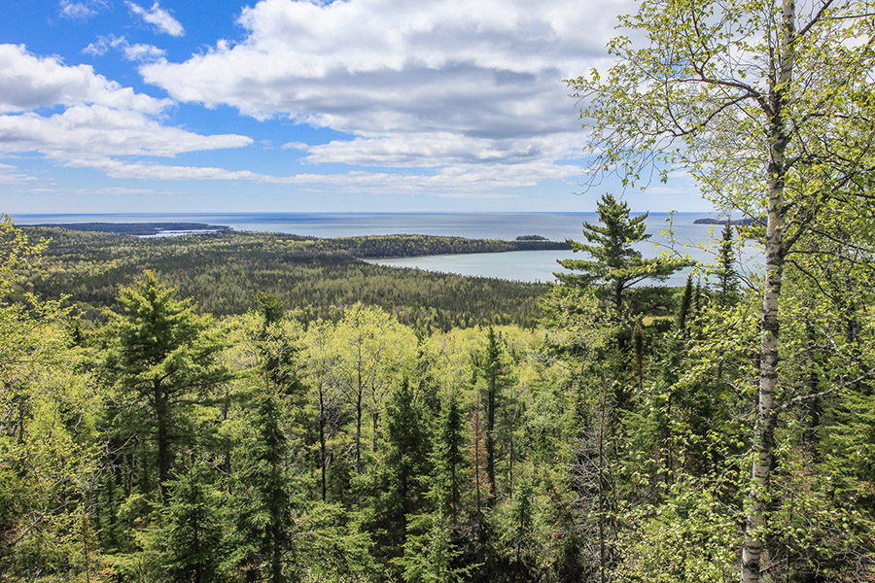

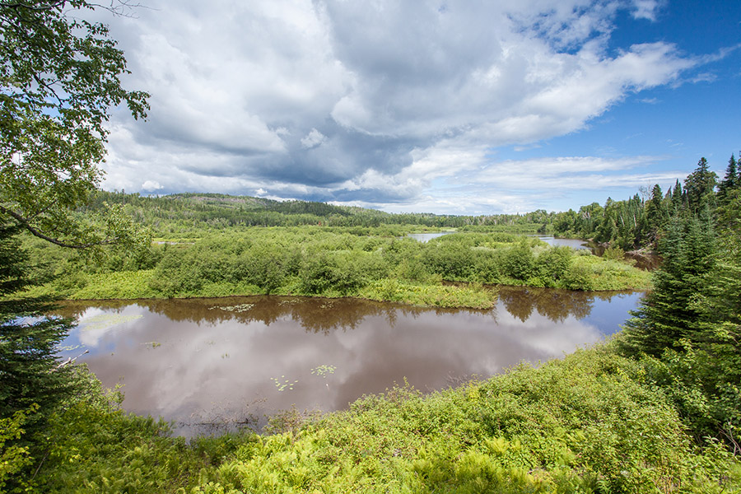

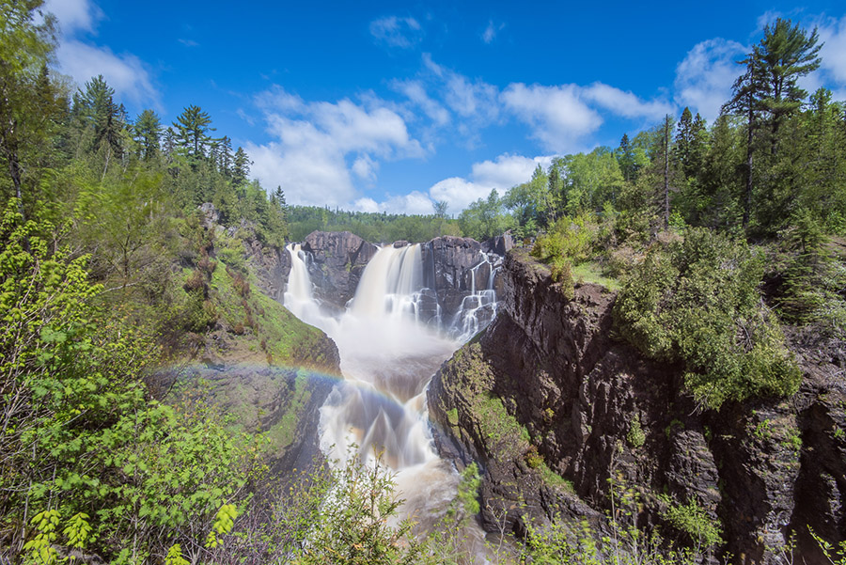

# Contact Information

## Address

9393 East Highway 61  
Grand Portage, MN 55605

### Website

https://www.dnr.state.mn.us/state_parks/park.html?id=spk00173#homepage

# Lake Shetek State Park

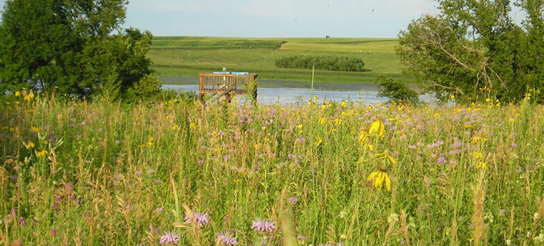

# Highlights

* Camping
* Fishing
* Bicycle Trail
* Shetek Monument and Koch Cabin

# Geology

A quiet hike on one of the park trails can yield a glimpse of a white-tailed deer, the sounds of bobolinks in the prairie, or the flight of a white pelican overhead. The wooded shoreline of Lake Shetek provides cover for white-tail deer, fox, mink, beaver, fox squirrels, muskrat, woodchuck and coyote.

# History

Visit the Koch Cabin and monument memorializing pioneer settlers. The park includes a swimming beach, boat launch, campgrounds and a scenic six-mile loop bicycle trail into the town of Currie. Boat, canoe, and kayak rentals are available.

# Landscape

Several wetlands in the park offer visitors an opportunity to view waterfowl, reptiles and amphibians. At Eastlick Marsh, interpretive signs and an observation deck with a spotting scope allow for close-up viewing and easy identification of coots, grebes, ducks, herons, and pelicans. Many species of waterfowl nest in and around the park in spring and early summer.

# Park Information

The word "Shetek" is Ojibwe for "pelican," a bird which visits Lake Shetek during the summer and fall. The park contains the largest lake in southwestern Minnesota, which forms the headwaters of the Des Moines River.

# Wildlife

Expect great fishing for walleye, northern, crappie, and bullheads. Loon Island, a 45-acre island on Lake Shetek, is accessible on foot via a causeway and includes an interpretive trail.



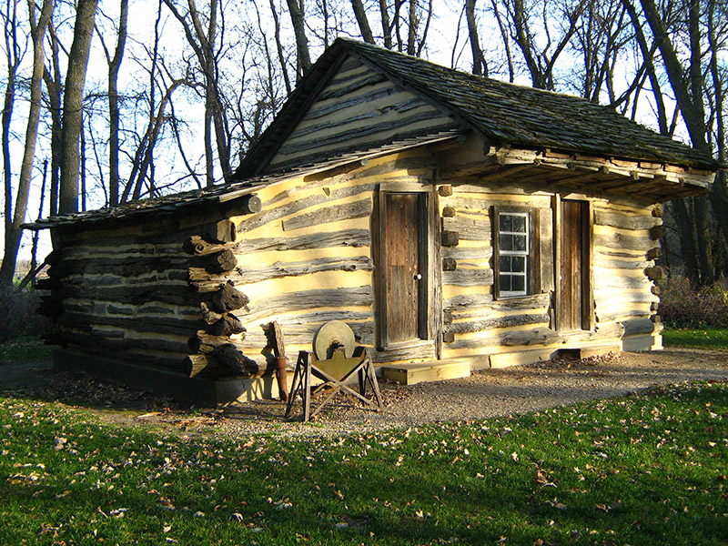

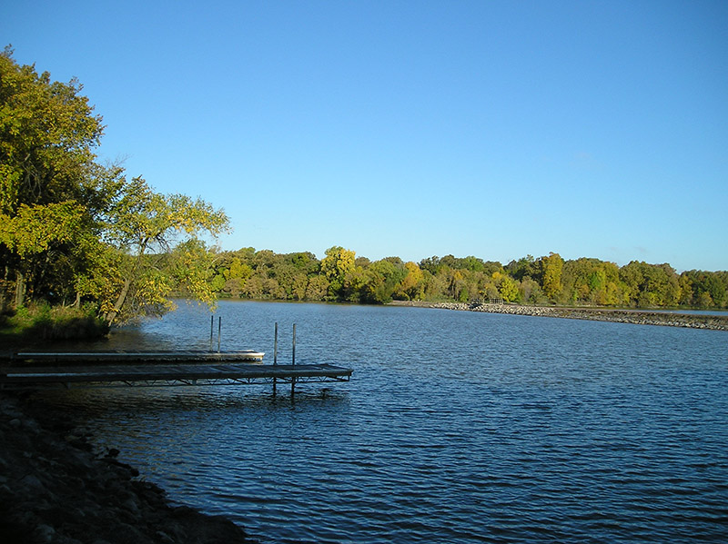

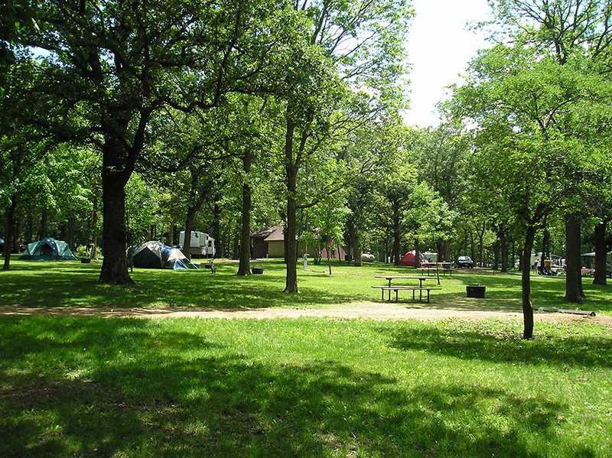

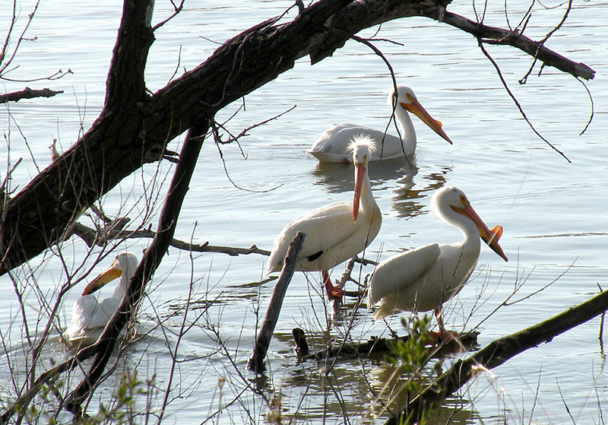

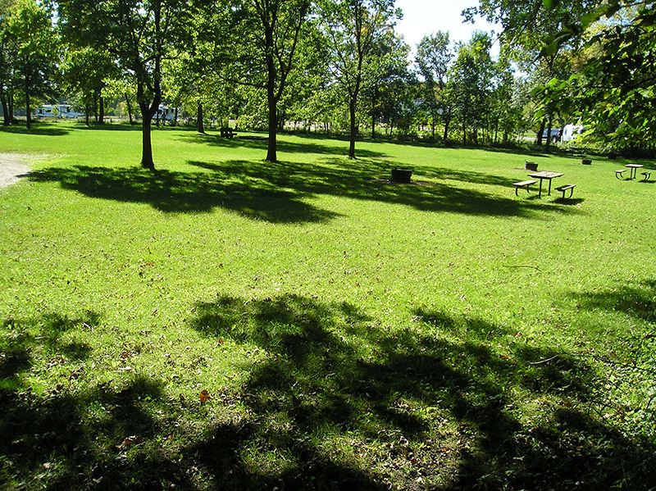

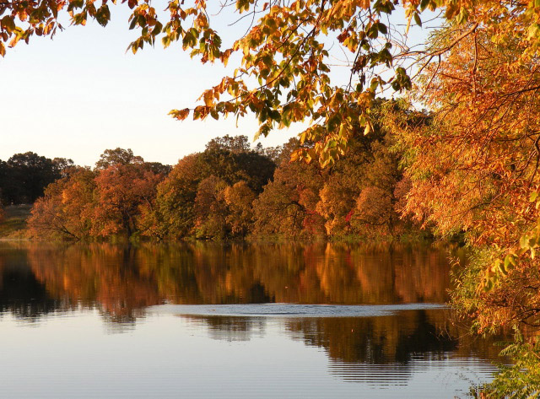

# Contact Information

## Address

163 State Park Road  
Currie, MN 56123

### Website

https://www.dnr.state.mn.us/state_parks/park.html?id=spk00220#homepage

# Interstate State Park

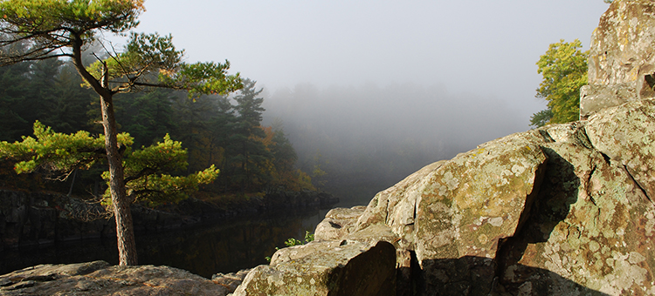

# Highlights

* Scenic River Views
* Canoeing
* Camping
* Fishing
* Rock Climbing
* Pothole Viewing

# Geology

About 1.1 billion years ago, earthquakes erupted from Taylors Falls to Lake Superior and caused at least 10 different lava flows. The hardened basalt rock from these lava flows partly formed the Dalles of the St. Croix and the bottom of the river. From 530 million years ago up until 70 million years ago, the state was washed by advancing and retreating seas. Evidence of these ancient seas is revealed in the sedimentary rocks and formations found in the park. These rocks contain fossil remains of ancient animals, evidence of various creatures, and ripple marks left in stone by the now vanished seas.

# History

In the 1800s, the threat of mining the St. Croix Dalles prompted leaders from Minnesota and Wisconsin to preserve the Dalles of the St. Croix River. Working together, the first interstate (Minnesota and Wisconsin) park in the nation was established. The Minnesota Legislature established the park in 1895; the Wisconsin Legislature followed in 1900. Today, visitors can hike both sides of the St. Croix River at Interstate Park in Minnesota and Wisconsin.

# Landscape

There have been many different St. Croix Valleys through the ages. The first formed about 70 million years ago and current valley formed about 10,000 years ago. A glacier formed both Glacial Lake Duluth, now Lake Superior, and Glacial Lake Grantsburg, now extinct. Glacial Lake Duluth was much larger than modern day Lake Superior. As this giant body of ice thawed, its meltwaters roared south to carve out the broad valley of the St. Croix. Only very resistant basalts were able to partially withstand the torrent, resulted in the dalles, potholes, and cliffs we see today.

# Park Information

There is so much to do at Interstate State Park, located on the beautiful St. Croix River. Visitors can climb the cliffs of the St. Croix River Dalles, canoe the flat-water, watch kayakers rush through the rapids, or relax on an excursion boat. Spring brings a great diversity of wildflowers and in fall, the St. Croix River Valley forest is ablaze in the autumn colors of red, gold, and orange. The geology that formed this park intrigues visitors, and brings geologists from all over the world. At least 10 different lava flows are exposed in the park, along with two distinct glacial deposits, and traces of old streams valleys and faults. During the summer, hike the trails and explore the glacial potholes that make this park unique.

# Wildlife

Creeks and springs that flow into the St. Croix River support white-tailed deer, skunks, raccoons, squirrels, and many different birds. There are many places in the park to listen for bird songs and owl calls.



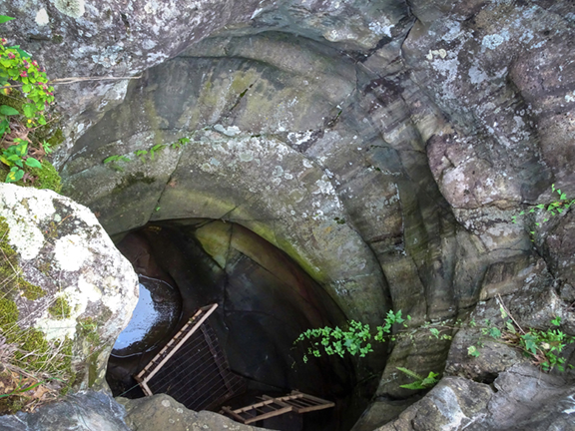

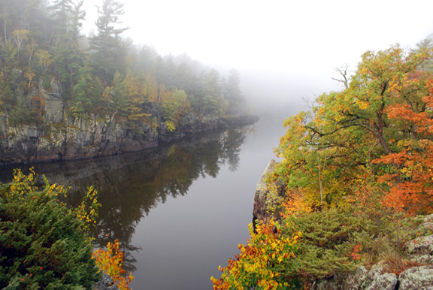

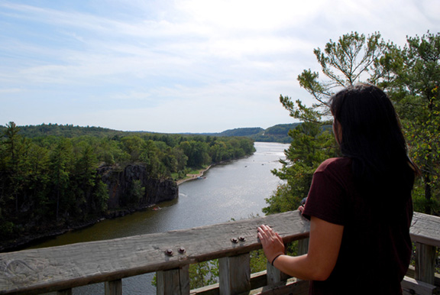

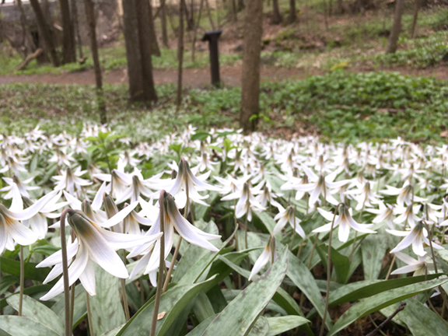

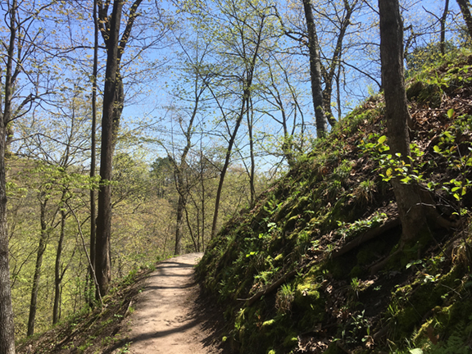

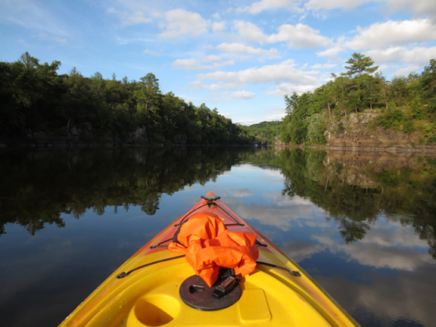

# Contact Information

## Address

PO Box 254  
307 Milltown Road  
Taylors Falls, MN 55084

### Website

https://www.dnr.state.mn.us/state_parks/park.html?id=spk00178#homepage

# Zippel Bay State Park

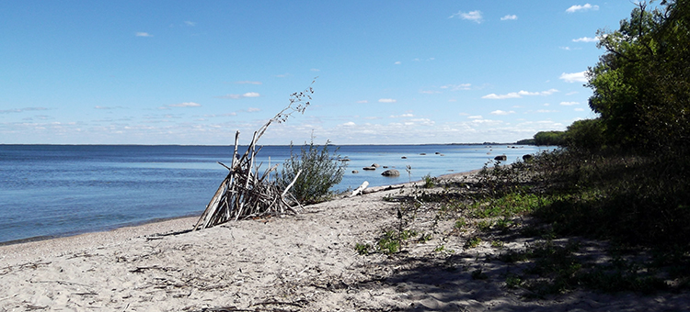

# Highlights

* Camping
* Fishing
* Beach
* Bird Watching
* Winter Recreation

# Geology

Evidence of prehistoric people has been found along the Rainy River, east of Zippel Bay and at other sites in the vicinity of Lake of the Woods giving indication of a long and varied history of human habitation of this region.

# History

The park's location on the northern border of the state affords opportunities to observe an interesting variety of wildlife not common elsewhere in the state. Park wildlife includes coyote, black bear, mink, fisher, otter and pine marten. Timber wolves are occasionally seen or heard in the park. Deer are commonly seen and, on occasion, a moose is sighted. On the list for birdwatching are white pelicans, double crested cormorants, four species of terns and herring, ring-billed, Franklin's and Bonaparte's gulls. Bald eagles nest near the park and osprey can be seen in the bay and along the lake. Sandhill cranes nest in the park and can be heard almost every day from spring to fall. In addition, the endangered piping plover may also be spotted along the beach front.

# Landscape

When French Explorer Pierre Gaultier de la Verendrye explored the area in 1732, he reported that it was populated by Cree, Monsonis, Assiniboine and Dakota Indians. At that time the Ojibwe had not yet pushed westward. La Verendrye established Fort St. Charles in the Northwest Angle of Lake of the Woods and from this outpost managed the exploration work that eventually opened up the north and west to a tide of fur traders. When the fort was abandoned in 1763, the British laid claim to the area. The next 75 years became known as the golden age of the French-Canadian Voyageurs who traded in the region.

# Park Information

After visiting Zippel Bay, you’ll remember the sunsets and the miles of white sand beach. The park is located on Lake of the Woods, one of the world’s largest lakes. The mood of the lake is always changing, from approaching storms that bring three-foot-high crashing waves and lightning flashes to an eerie stillness, broken only by the faint calls of a thousand raucous gulls, out of sight in the lake’s interior. In summer, the 3,000-acre park offers a swimming beach and picnic area on the big lake, drive-in campsites and a group camp, a marina on Zippel Bay and a stone jetty providing protected access to Lake of the Woods.

# Wildlife

Birding is excellent—be sure to watch for sandhill cranes and piping plovers. In the winter, three miles of snowmobile trail provide access to the lake, which snowmobilers will find dotted with fish houses making virtual towns on the ice. Seven miles of groomed cross-country trails wind to the lakeshore through jack pine, birch, and open fields.



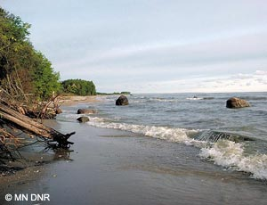



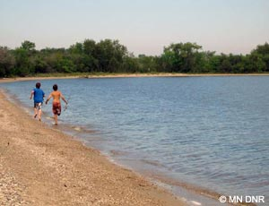

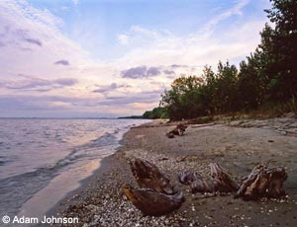



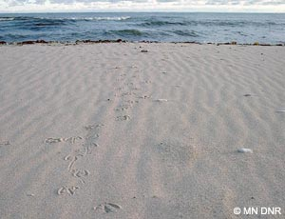

# Contact Information

## Address

3684 54th Avenue Northwest  
Williams, MN 56686

### Website

https://www.dnr.state.mn.us/state_parks/park.html?id=spk00284#homepage